**OPERATING SYSTEM ASSIGNMENT – 1**

**Team Members :**

Koushik Ragavendran

Janaranjani

1)a)

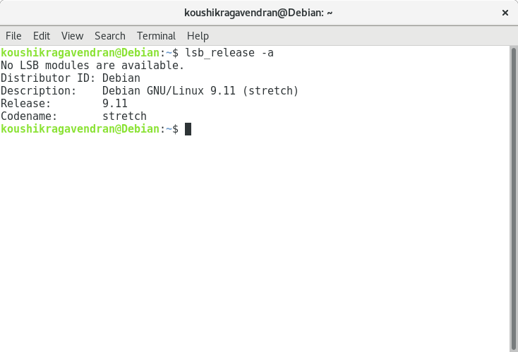

1)b)

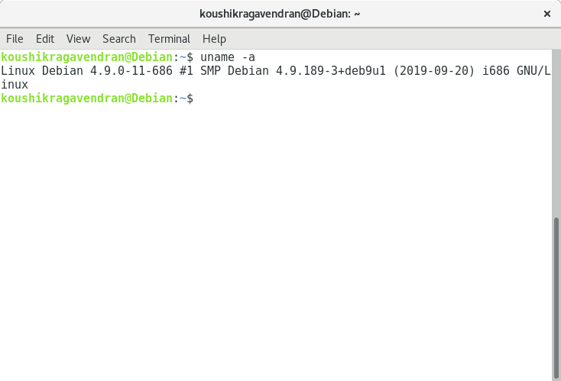

1)c)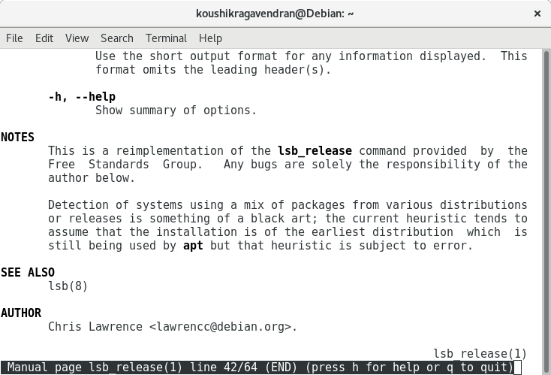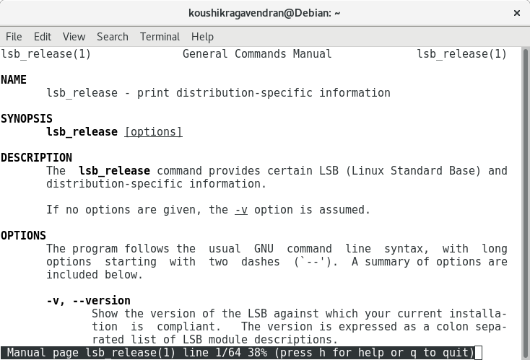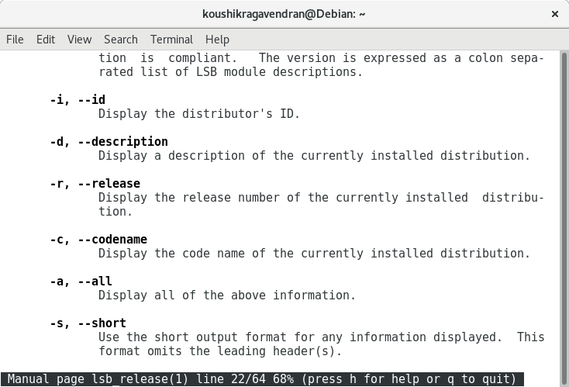

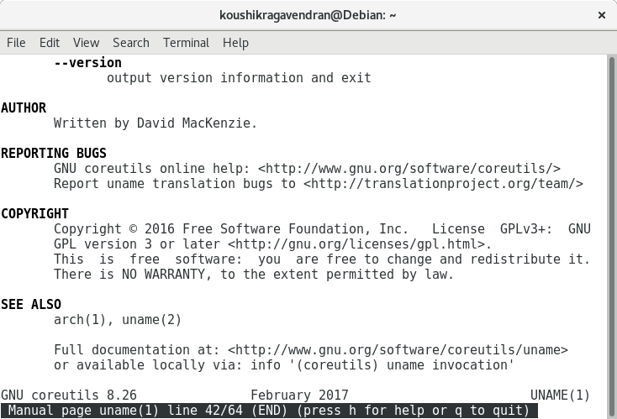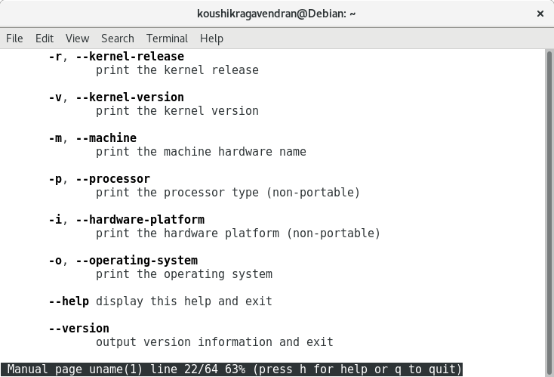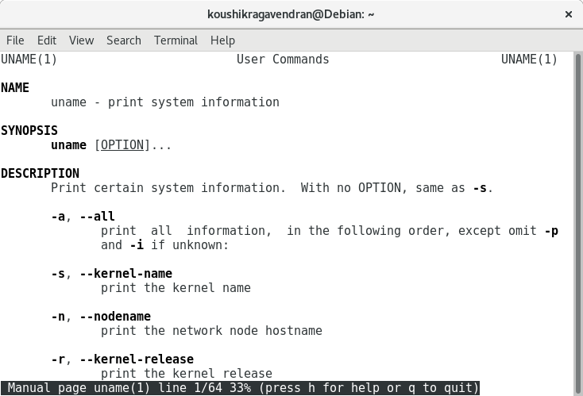

2)

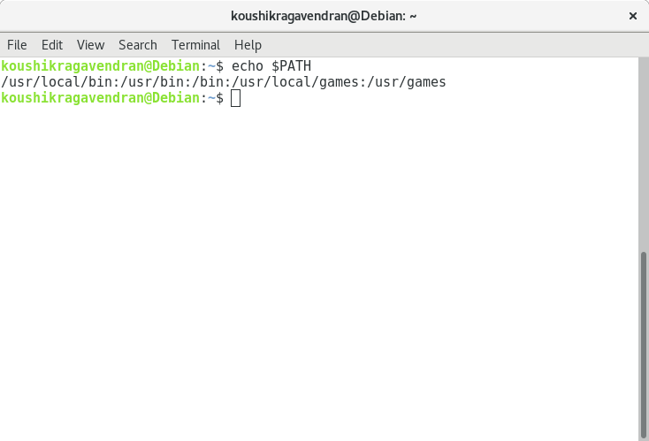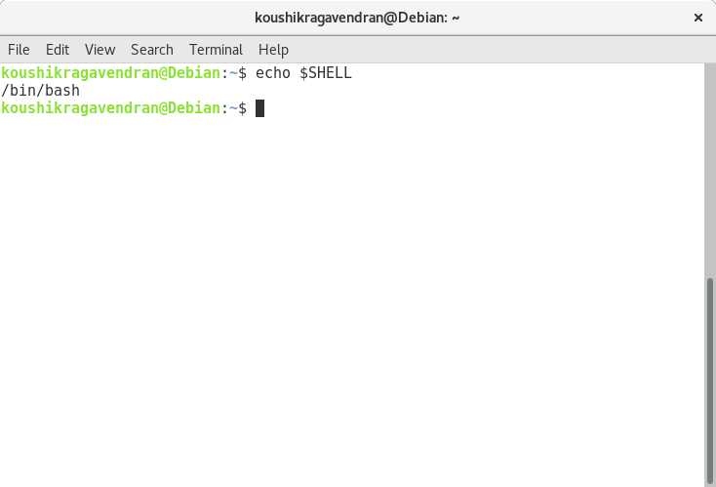

3)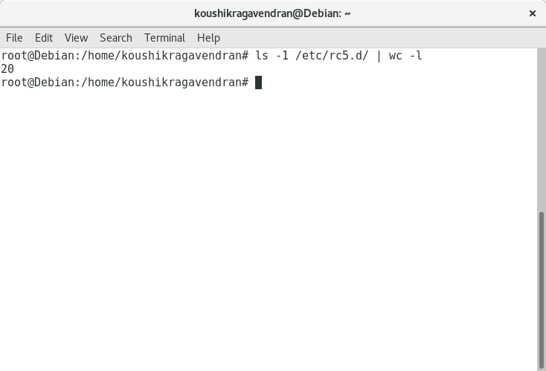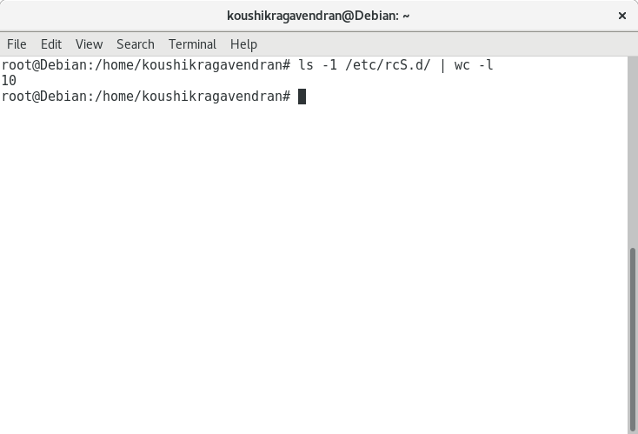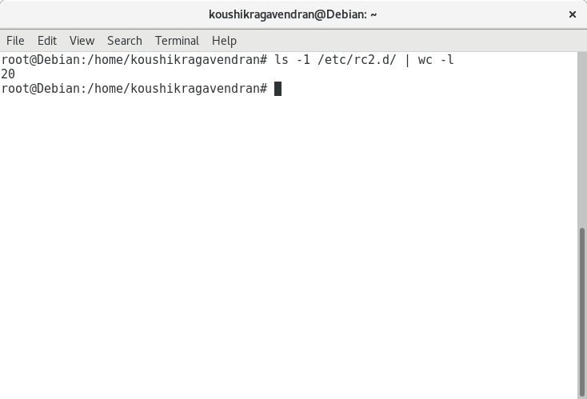

4)

(a) Difference between systemd and init

|  |  |
| --- | --- |
| **Systemd** | **Init** |
| It’s also a background process with PID = 1, it starts the processes in a parallel manner. | With Process ID (PID) = 1, this runs in the background and starts the process in serial manner (i.e only when one process startup is complete the second will be started). |
| Booting time is low and computational overhead is less | Booting time is high |
| Supports GUI | It doesn’t support GUI |
| Limited resource per service | Unlimited resource per service |
| Automatically kills the process at logout | It doesn’t kill the process at logout |
| If main service fails the dependent services are bypassed. | Even if main service fails it checks for sub-services |
| It has no run levels, it has configuration files named unit files and activates the services based on the unit file | It has run levels. The services corresponding to the run levels will be activated. |